TOURNAMENT RULES:
Force construction: 800pts 2nd Edition Core Rules.

Recon Roll
At the beginning of each game, players will roll Recon by using their Command Dice pool. The player with the highest result will earn Initiative which they can give to their opponent if they wish. The player with Initiative can pick their preferred table side and deploys first.

During deployment, the player with the Initiative has the option to hold back a number of units equal to the difference in the Recon roll. These units are not in Reserve, but instead can be deployed after your opponent deploys their Strike Force.

Objective
Each scenario will describe the method of placing Objectives on the board. Some Objectives require Unit Strength to capture. As a reminder, if a Troop or Specialist unit is reduced to a single model, its Unit Strength becomes 0. This does not apply to Support or Command units.

Game Length
Games will last a total of 5 rounds or 90 minutes, whichever comes first.

Scenario 1: Take and Hold
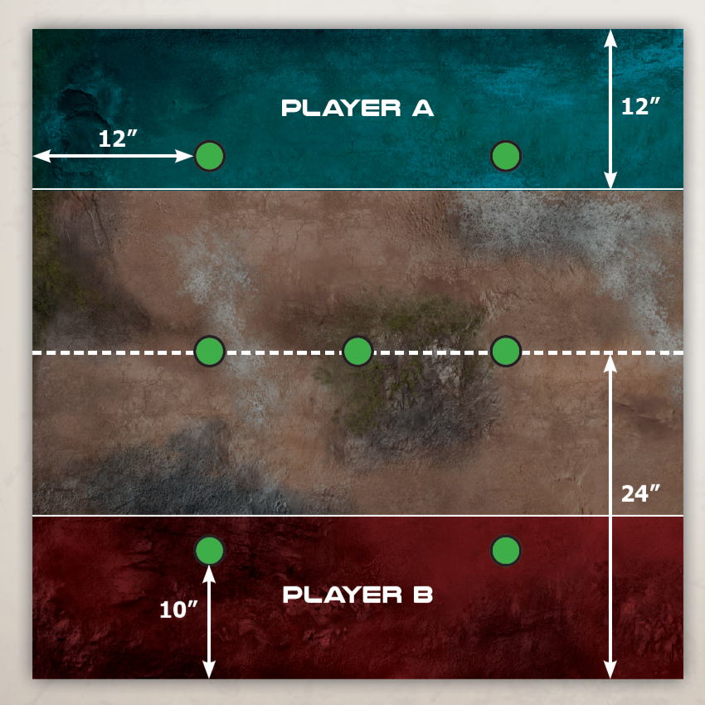
Gameplay follows Take and Hold on pg 54 of Core Rulebook
Objectives
Place 2 Objectives in each deployment zone 10” in from the back of the board and 12” in from the side. Place 2 Objectives along the center line of the table 12” in from the side edges. Place 1 Objective directly in the table center.

Victory Points
VPs are awarded at the end of each Round. Each Objective you hold in your own deployment zone is worth 1VP. The Objectives in the center are worth 2VPs. Objectives you hold in your opponent’s deployment zone are worth 4VP. The player with the most VPs at the end of the game is the winner.

At the end of the game, score the round for Tournament Points (TP) using the following chart:
TP | Objective | Scoring Conditions
+5 | Primary | Score more Victory Points than opponent at the end of the game. If the game is a draw, both Players score 2 tournament points.
+1 | Secondary | A Player who has a model in the enemy deployment zone will receive 1TP. Both Players may earn this and is awarded once per game.
+2 | Bounty Hunting | Killing an opponent’s Command Unit will earn 2TP for the Player. Both Players may earn this and is awarded once per game.

Scenario 2: Secure the Sector
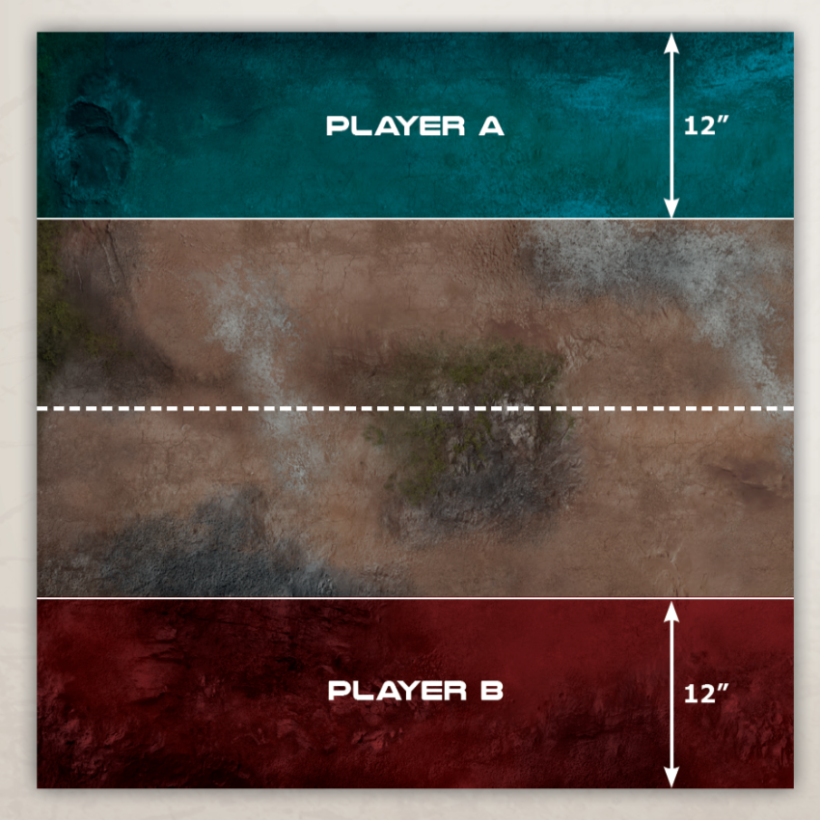
Gameplay follows Secure the Sector on pg 55 of Core Rulebook
Deployment
Players will start by deploying 50% (rounding up) of their Strike Force. The remainder will be held in Reserve and will be available from Round 2 onwards.

Victory Points
Divide the table into 6 24”x24” squares. At the end of the game user the Unit Strength of all units in each square to determine who controls the square. Players will score 1VP for each square they control at the end of the game. The player with the most VPs at the end of the game is the winner.

At the end of the game, score the round for Tournament Points (TP) using the following chart:
TP | Objective | Scoring Conditions
+5 | Primary | Score more Victory Points than opponent at the end of the game. If the game is a draw, both Players score 2 tournament points.
+1 | Secondary | A Player who has a model in the enemy deployment zone will receive 1TP. Both Players may earn this and is awarded once per game.
+2 | Bounty Hunting | Killing an opponent’s Command Unit will earn 2TP for the Player. Both Players may earn this and is awarded once per game.

Scenario 3: Control the Intel
Gameplay follows Secure the Sector on pg 53 of Core Rulebook
Objectives
After selecting Deployment Zones but prior to Deployment, the player with Initiative rolls a D4+2 to determine the number of Objectives. Starting with that player and alternative afterwards, place Objectives in your opponent’s half of the table but outside their Deployment Zone and no closer than 6” from any other Objective

Victory Points
VPs are awarded at the end of each Round. Each Objective controlled is worth 1VP. The player with the most VPs at the end of the game is the winner.

At the end of the game, score the round for Tournament Points (TP) using the following chart:
TP | Objective | Scoring Conditions
+5 | Primary | Score more Victory Points than opponent at the end of the game. If the game is a draw, both Players score 2 tournament points.
+1 | Secondary | A Player who has a model in the enemy deployment zone will receive 1TP. Both Players may earn this and is awarded once per game.
+2 | Bounty Hunting | Killing an opponent’s Command Unit will earn 2TP for the Player. Both Players may earn this and is awarded once per game.

Firefight Tournament
Sportsmanship Score Card
.

Rank your favorite opponents. Sportsman points will be awarded based on their ranking and calculated at the end of the tournament to determine the Best Sportsman

Points | Player Name
+4
+3
+2
+1

Turn in this sheet to Tournament Organizer when complete

Firefight Tournament Scoring Sheet
Turn in this sheet to Tournament Organizer when complete.

Round: 1 2 3 4
[Circle the round number]

Player One’s Name
Player One’s Total Tournament Points (TP)
Player One’s Total Victory Points (VP)
Did Player One Win, Lose, or Draw?
Player One Unit Kills
Player Two’s Name
Player Two’s Total Tournament Points (TP)
Player Two’s Total Victory Points (VP)
Did Player Two Win, Lose, or Draw?
Player Two Unit Kills

Both players must sign this sheet before turning it in.
Player One’s Signature | Player Two’s Signature

Firefight Tournament Scoring Sheet
Turn in this sheet to Tournament Organizer when complete.

Round: 1 2 3 4
[Circle the round number]

Player One’s Name
Player One’s Total Tournament Points (TP)
Player One’s Total Victory Points (VP)
Did Player One Win, Lose, or Draw?
Player One Unit Kills
Player Two’s Name
Player Two’s Total Tournament Points (TP)
Player Two’s Total Victory Points (VP)
Did Player Two Win, Lose, or Draw?
Player Two Unit Kills

Both players must sign this sheet before turning it in.
Player One’s Signature | Player Two’s Signature

Firefight Tournament Scoring Sheet
Turn in this sheet to Tournament Organizer when complete.

Round: 1 2 3 4
[Circle the round number]

Player One’s Name
Player One’s Total Tournament Points (TP)
Player One’s Total Victory Points (VP)
Did Player One Win, Lose, or Draw?
Player One Unit Kills
Player Two’s Name
Player Two’s Total Tournament Points (TP)
Player Two’s Total Victory Points (VP)
Did Player Two Win, Lose, or Draw?
Player Two Unit Kills

Both players must sign this sheet before turning it in.
Player One’s Signature | Player Two’s Signature

